INTRODUCTION TO GCP AND IAM
Agenda
- Introduction
- Features
- Benefits
- Use Cases of GCP
- GCP vs AWS vs Azure
- Setup of GCP
- Introduction to IAM
- Features of IAM
- Key Concepts of IAM
- Creating Roles in IAM
- Assigning different roles to a user in IAM
- Checking Permissions
- Creating Custom Role with Specific Permissions
Google Cloud Platform (GCP) is a suite of cloud computing services offered by Google. It provides a wide range of services, including computing, storage, databases, networking, artificial intelligence, and security.
Features of GCP:
1️. Fully Managed Services for Developers & EnterprisesGCP provides a wide range of managed services, allowing developers and businesses to focus on innovation without worrying about infrastructure maintenance, scaling, or backend operations.
2. Scalable Infrastructure with Global AvailabilityWith a vast network of data centers across the world, GCP ensures high availability and reliability. It offers flexible computing power that scales automatically based on demand, ensuring optimal performance.
3. AI/ML Capabilities with Google’s Advanced AI ModelsLeveraging Google’s cutting-edge artificial intelligence, GCP provides powerful AI/ML tools such as Vertex AI, TensorFlow, and AutoML. These tools help businesses build, train, and deploy machine learning models effortlessly.
4. Secure and Compliant with Industry StandardsSecurity is a top priority for GCP, offering built-in protection against threats, encryption for data at rest and in transit, and compliance with global security standards such as GDPR, ISO, and SOC.
5. Serverless and Containerized EnvironmentsGCP supports modern cloud-native applications with services like Cloud Run, Kubernetes Engine, and App Engine, enabling developers to build, deploy, and scale applications without managing servers.
Benefits of GCP:
- Performance & Scalability – Runs on Google’s global infrastructure.
- Cost-Effective – Pay-as-you-go pricing with free-tier options.
- Security – Built-in security, compliance, and IAM.
- Big Data & AI/ML – Pre-trained AI models and BigQuery.
- Multi-cloud & Hybrid Support – Works with AWS & Azure.
Use Cases of GCP:
- Hosting Websites & Applications – Scalable web hosting
- Big Data & Analytics – Running queries on large datasets
- AI & Machine Learning – Image recognition, NLP, and data science
- CI/CD & DevOps – Seamless integration with development pipelines
- Hybrid Cloud & Kubernetes – Runs workloads across multiple clouds
GCP vs AWS vs Azure:
Feature | GCP | AWS | Azure
Compute Services | Compute Engine | EC2 | Virtual Machines
Storage Services | Cloud Storage | S3 | Blob Storage
Database Services | BigQuery, Cloud SQL | RDS, DynamoDB | SQL Database, Cosmos DB
AI/ML | Vertex AI | SageMaker | Azure ML
Networking | VPC, Cloud CDN | VPC, Route 53 | Virtual Network
Pricing Model | Pay-as-you-go | Pay-as-you-go | Pay-as-you-go
Multi-cloud Support | Anthos | Outposts | Arc
What should one select?
- GCP is best for AI/ML, Big Data, and networking.
- AWS is the most mature with a vast ecosystem.
- Azure is enterprise-friendly and integrates well with Microsoft products.
Setup of Google Cloud Platform:
Step 1: Go the following Google Cloud Website:
https://cloud.google.com/
Step 2: Click on “Start Free”.
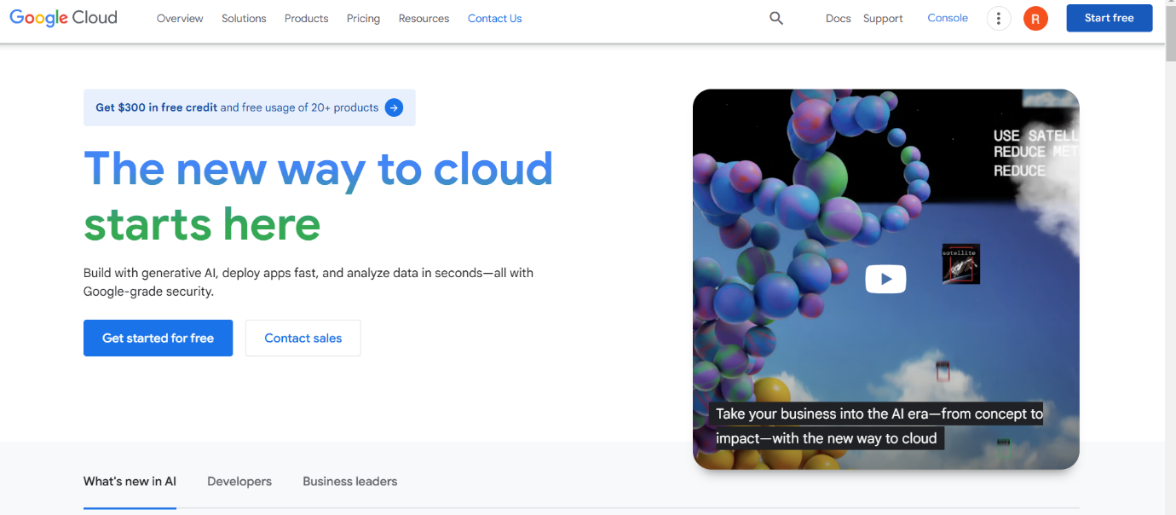
Step 3: Now, set up the Payment mode and add the personal details required and then this homepage will appear on your screen.
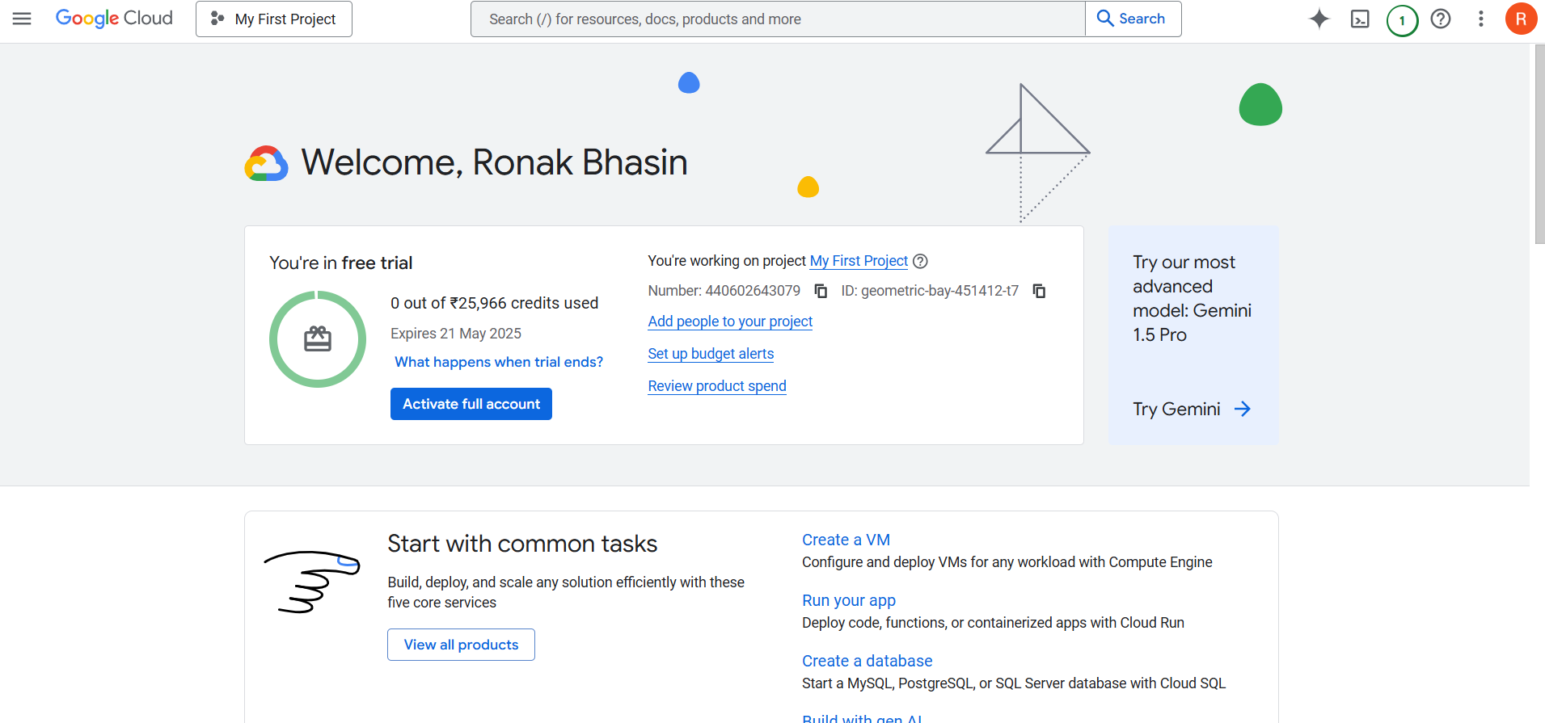
IAM:
Introduction:
Identity and Access Management (IAM) in GCP is a framework that allows administrators to manage access to cloud resources securely and efficiently. It enables fine-grained access control by defining who (users, groups, service accounts) can perform what (roles, permissions) on which resources.
Features of IAM:
- Security: Ensures only authorized users can access critical resources.
- Least Privilege: Grants only the permissions required for a task.
- Scalability: Easily manage access across multiple projects and resources.
- Auditability: Provides logs for monitoring and compliance.
Menu of IAM in Google Cloud Console :
After searching IAM, on the left side of Console, you will see the various options available as shown, here is the description of these options which you can choose.
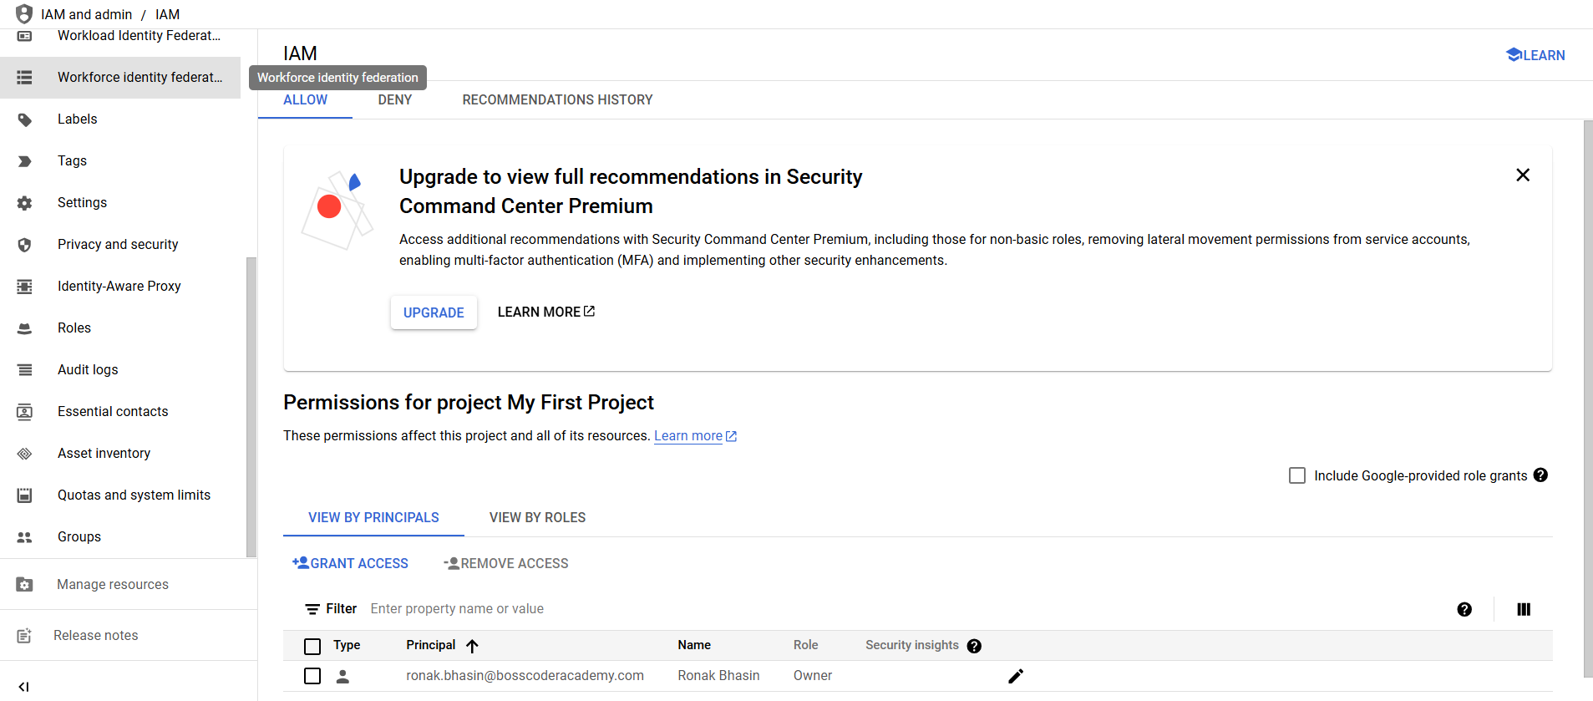
1. PAM (Privileged Access Management) – Likely used for managing privileged roles and access to sensitive resources.
2. Principal Access Boundary – Defines boundaries for access control to enforce security policies.
3. Organisations – Manages organizational structures and hierarchy within Google Cloud.
4. Identity and Organisation – Deals with identity management and organization-wide settings.
5. Policy Troubleshooter – A tool for diagnosing permission issues and resolving access problems.
6. Policy Analyser – Helps in reviewing and understanding IAM policies.
7. Organisation Policies – Defines constraints and security policies at the organization level.
8. Service Accounts – Manages service accounts used for application authentication and API access.
9. Workload Identity Federation – Allows external identities to access Google Cloud resources without needing service account keys.
10. Workforce Identity Federation – Provides identity federation for workforce users, enabling them to access GCP using external identity providers.
11. Labels – Used to organize and manage cloud resources effectively.
12. Tags – Provide a way to manage resources across projects and organizations with policies.
13. Settings – Contains global IAM settings, such as security configurations and policy enforcement.
14. Privacy and Security – Manages security settings, compliance controls, and privacy policies.
15. Identity-Aware Proxy (IAP) – Provides secure access to applications running on Google Cloud, allowing authentication and authorization.
16. Roles – Defines and manages custom roles and permissions for different users and groups.
17. Audit Logs – Tracks changes and access events within IAM for security and compliance monitoring.
18. Essential Contacts – Lists key contacts for security, compliance, and operational notifications.
19. Asset Inventory – Provides a comprehensive list of cloud resources for visibility and tracking.
20. Quotas and System Limits – Displays and manages resource quotas and usage limits in Google Cloud.
21. Groups – Manages IAM groups, which allow multiple users to share permissions collectively.
Key concepts of IAM:
1. Principals (Users, Groups, Service Accounts):
Principals are the entities that can request access to Google Cloud resources. They represent who or what is making a request.
- Users – Individual human users with a Google account or a Cloud Identity/Firebase account.
- Groups – A collection of users managed in Google Workspace or Cloud Identity, which allows permissions to be assigned collectively.
- Service Accounts – Special accounts used by applications, workloads, or services to authenticate and access GCP resources without requiring user credentials.
2. Roles (Basic, Predefined, Custom):
Roles define a set of permissions that determine what actions a principal can perform on a resource.
- Basic Roles – Legacy roles that provide broad access:
  - Owner – Full access to all resources.
  - Editor – Modify resources but cannot manage IAM.
  - Viewer – Read-only access.
- Predefined Roles – Google-managed roles with fine-grained permissions tailored for specific services. Example: roles/storage.objectViewer for viewing objects in Cloud Storage.
- Custom Roles – User-defined roles where permissions can be tailored based on business needs.
3. Policies & Permissions:
- Policies define which principals have what roles at which resource level. These policies use an "Allow" model (no explicit deny).
- Permissions control what actions a role can perform, such as compute.instances.start. Permissions are assigned indirectly via roles.
NOTE: The maximum number of permissions you can include in a single role is 500.
GCP IAM vs. AWS IAM vs. Azure IAM:
Feature | GCP IAM (Google Cloud) | AWS IAM (Amazon Web Services) | Azure IAM (Microsoft Azure)
Principals | Users, Groups, Service Accounts | Users, Groups, Roles | Users, Groups, Service Principals, Managed Identities
Roles | Basic (Owner, Editor, Viewer), Predefined, Custom Roles | AWS-Managed Policies, Customer-Managed Policies, Inline Policies | Built-in Roles, Custom Roles
Service Accounts | Yes (acts as identity for applications) | No direct equivalent, IAM Roles used for applications | Yes (similar to GCP)
IAM Policies | JSON-based policy binding | JSON-based IAM policies with Allow/Deny statements | Role-based access control (RBAC)
Access Model | Role-based (RBAC) | Policy-based (RBAC + ABAC) | Role-based (RBAC)
Policy Enforcement | Inheritance-based at Org, Folder, Project, and Resource levels | Attached directly to Users, Groups, Roles, and Resources | Inheritance-based at Management Group, Subscription, Resource Group, and Resource levels
Permissions | Assigned via roles, no explicit deny | Permissions assigned via policies with Allow/Deny | Assigned via roles, no explicit deny
Temporary Credentials | Short-lived OAuth 2.0 tokens via Service Accounts | Temporary security credentials via STS (AssumeRole) | Managed Identities for Azure resources
Federation | Supports Google Workspace, Cloud Identity, and external identity providers | Supports Active Directory, SAML, and OpenID Connect | Supports Azure AD, SAML, OpenID Connect
Logging & Auditing | Cloud Audit Logs | CloudTrail | Azure Monitor, Azure AD Logs
Fine-grained Access | Uses IAM Conditions for context-aware policies | AWS IAM Policies allow attribute-based access control (ABAC) | Uses Conditional Access policies in Azure AD
Creating Roles in IAM:
Step 1: Search IAM, then from the menu go to Roles.
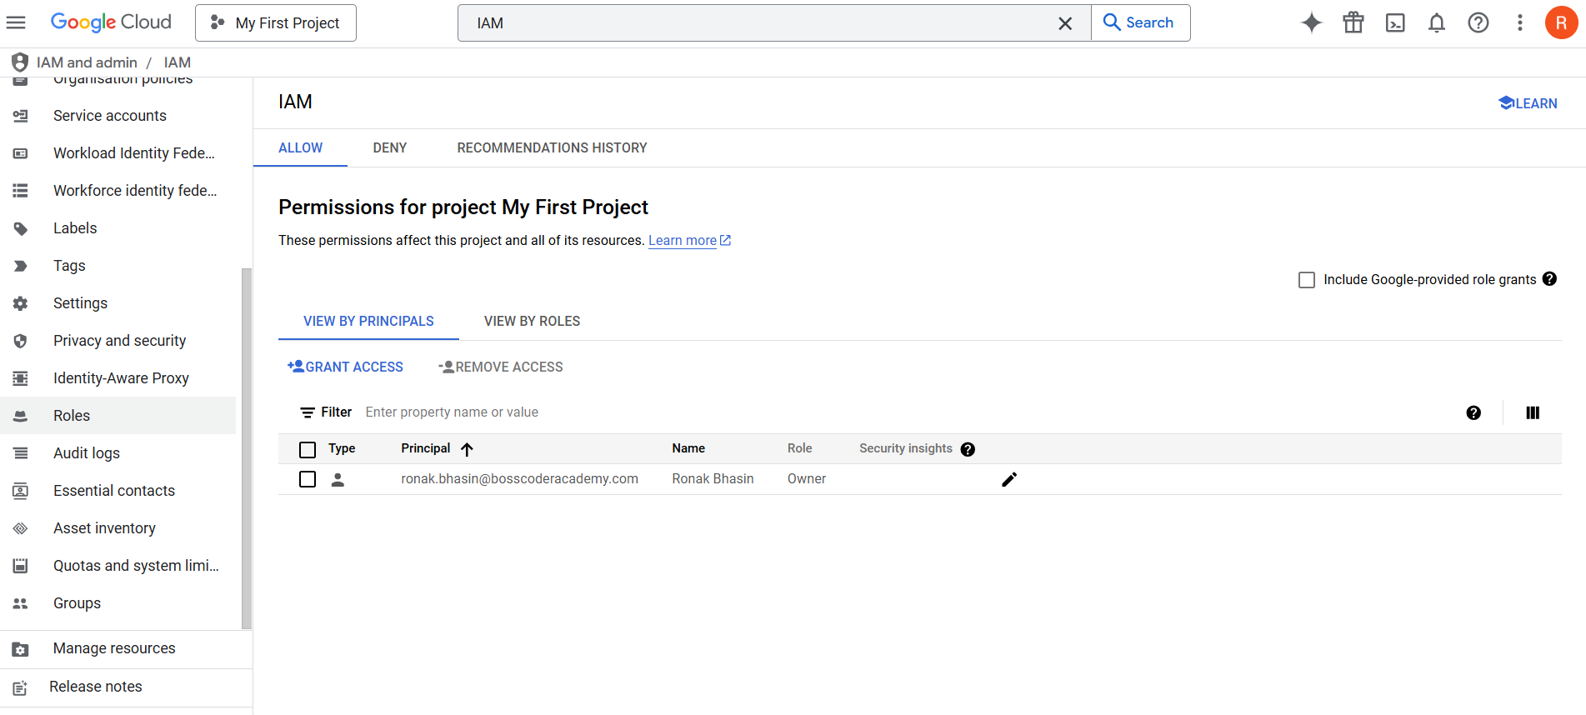
Step 2: From this Window, click on Create Role.
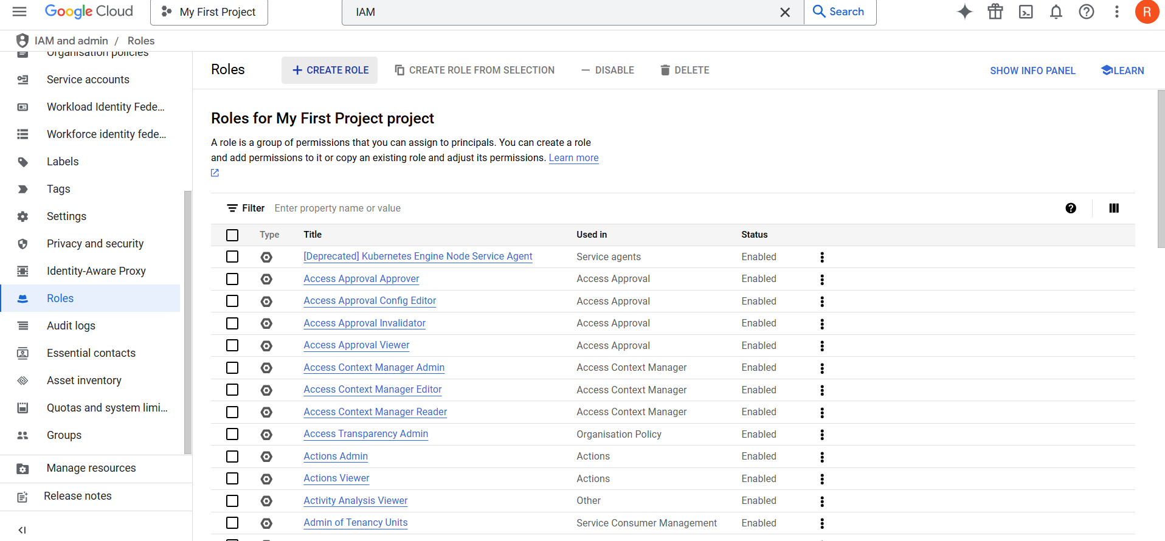
Step 3: Now, click on Create Role and enter the details and add permissions.
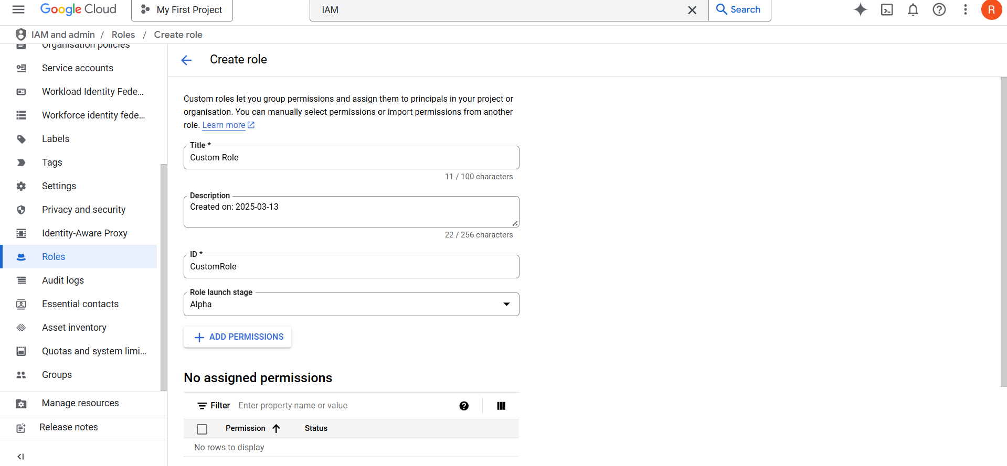
Step 4: Now, click on Create.
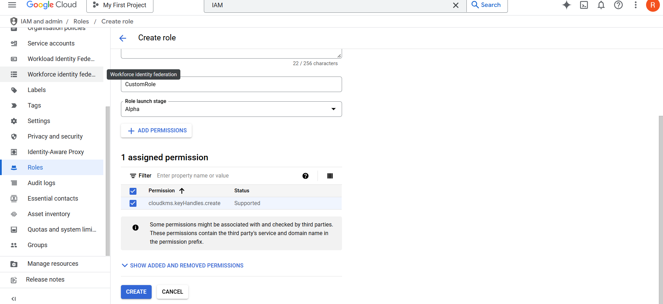
Assigning Different Roles to a User in IAM:
Step 1: Open the Google Cloud Console and go to IAM & Admin > IAM.
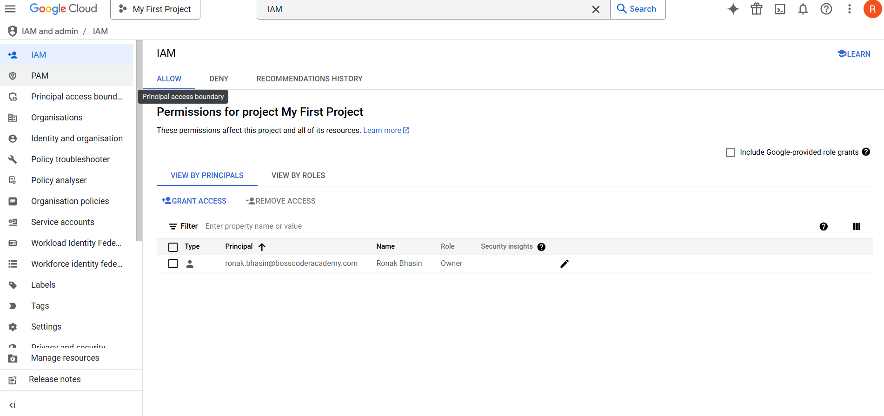
Step 2: Find the user and click "Edit Principal." (Anyone)
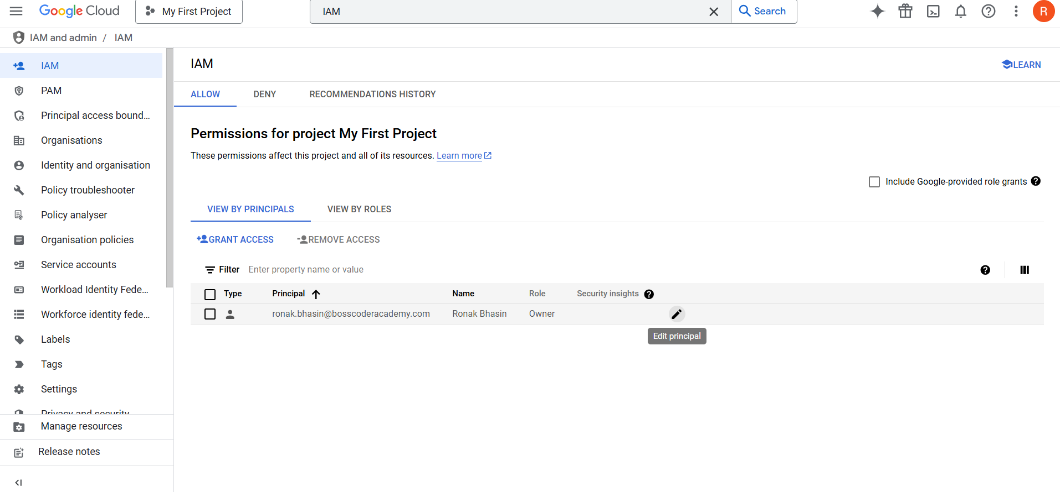
Step 3: Click "Add Another Role" to assign additional roles and select the desired roles from the dropdown.
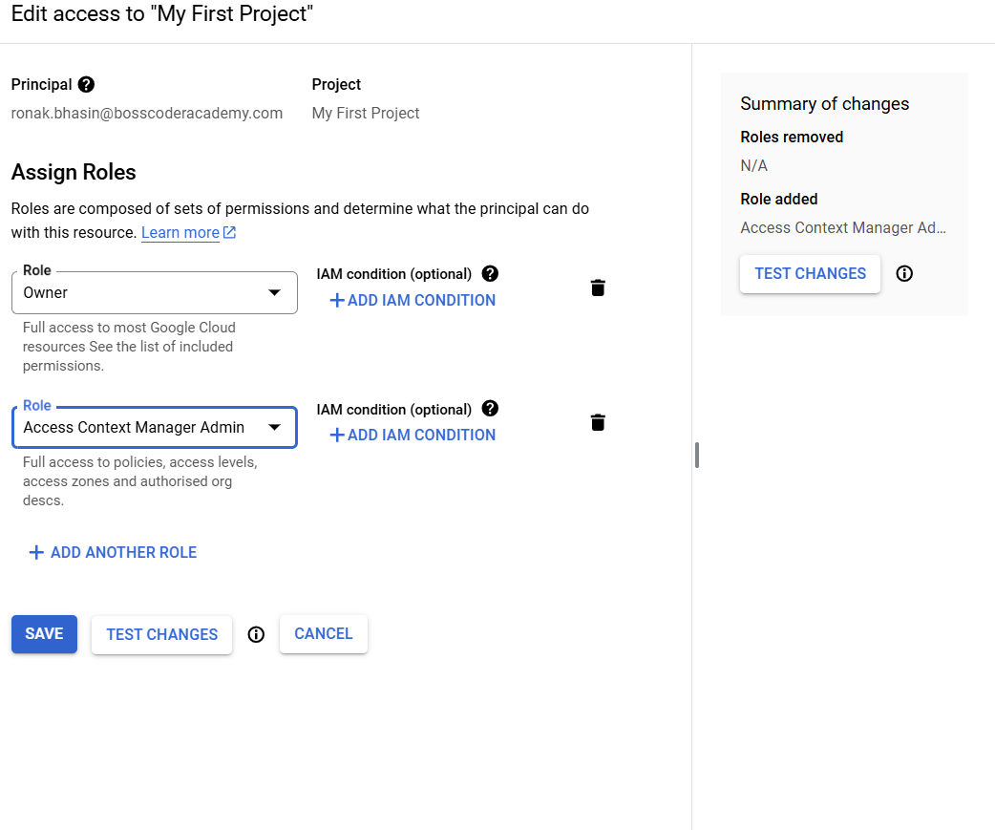
Step 4: Click "Save" to apply the changes.
Checking Permissions for Different Roles:
Step 1: Open the Google Cloud Console and go to IAM & Admin > Roles.
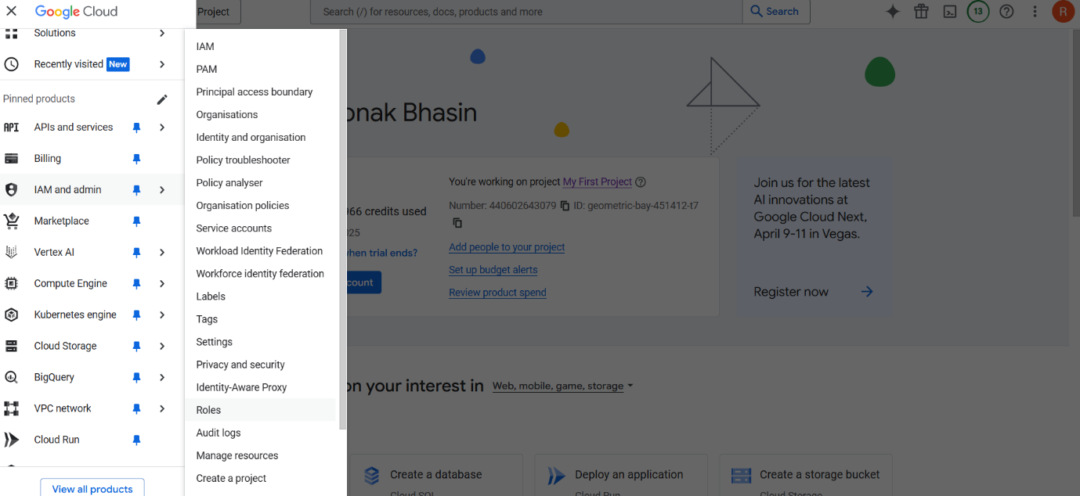
Step 2: Use the search bar to find and select a specific role.
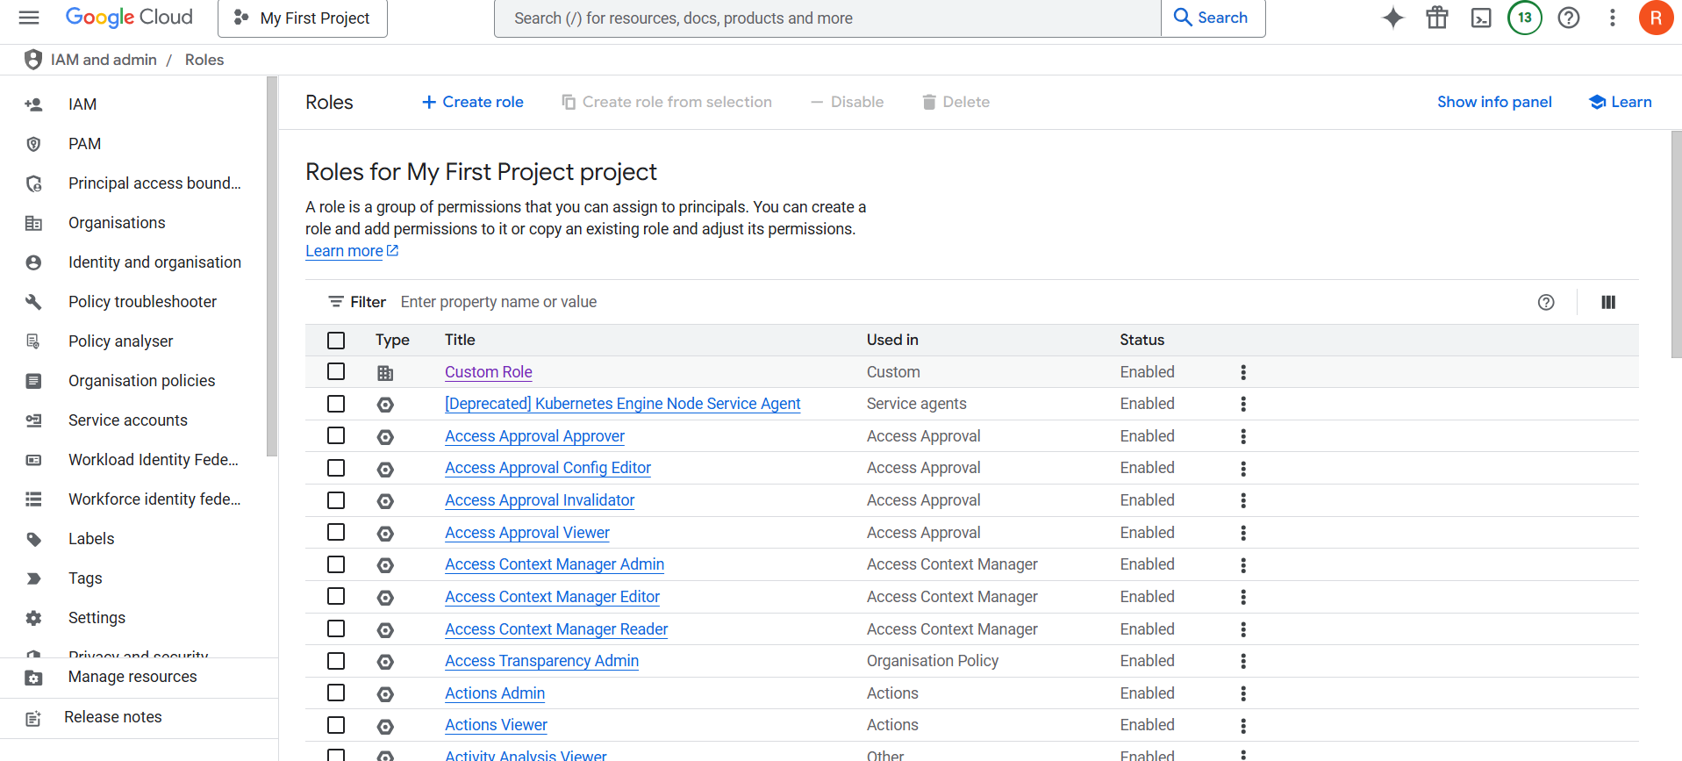
Step 3: Click on the role to view its assigned permissions.
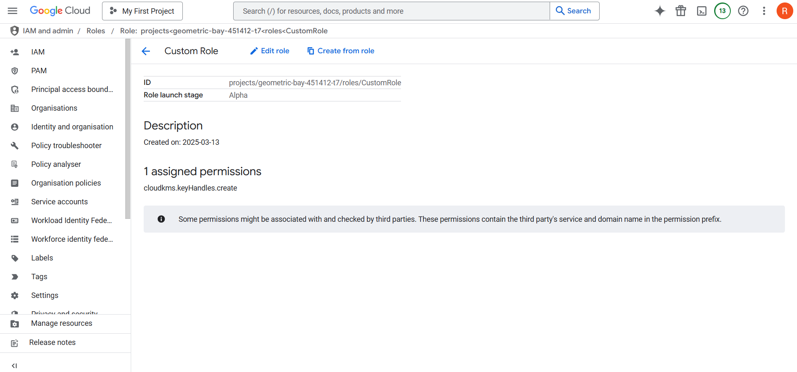
Step 4: Similarly, Go to IAM & Admin > IAM and select a user or service account.
Step 5: View assigned roles and check their corresponding permissions.
Create a Custom Role with Specific Permissions:
Step 1: Open the Google Cloud Console and go to IAM & Admin > Roles.
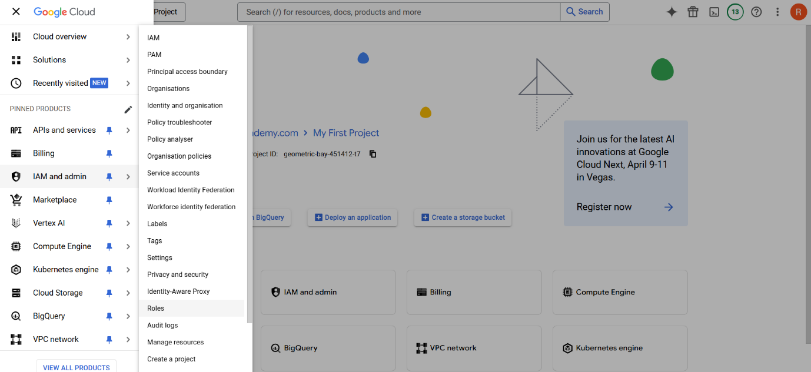
Step 2: Click "Create Role," enter a name, title, and description, and set the launch stage.
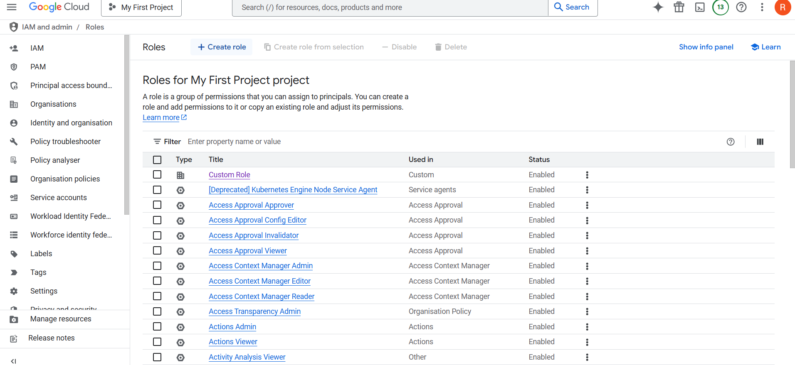
Step 3: Click "Add Permissions," search for and select the required permissions.
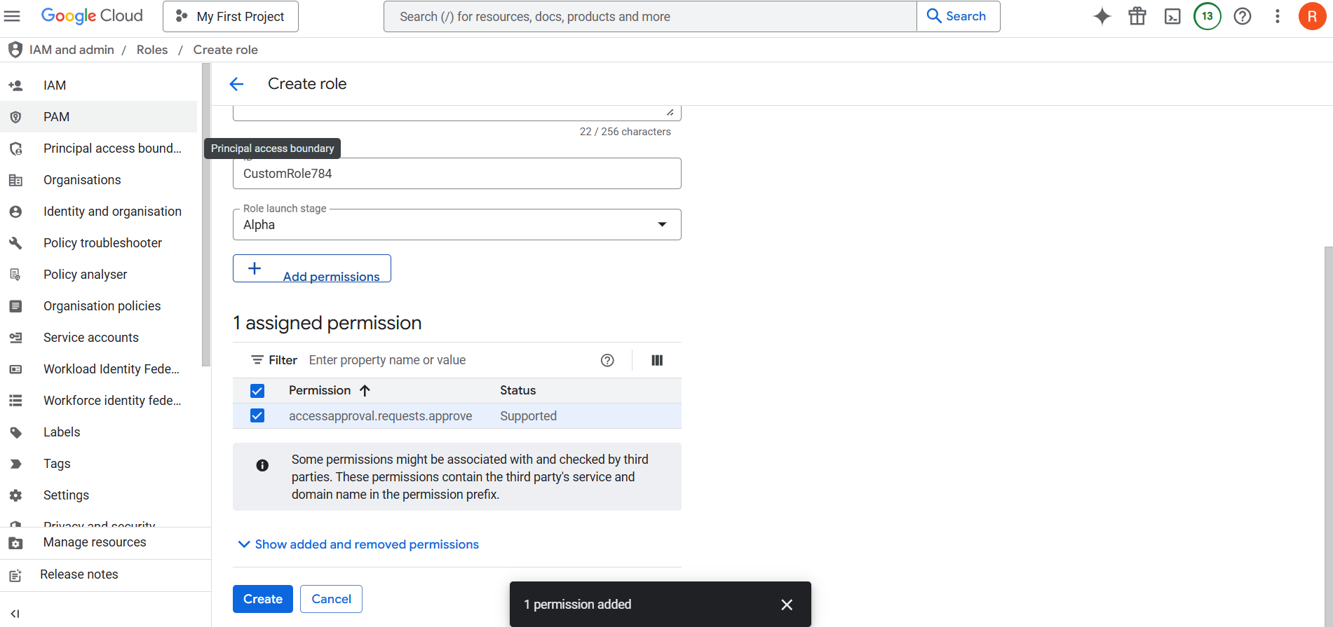
Step 4: Click "Create" to finalize the role.
Step 5: Go to IAM & Admin > IAM, add a user, select the custom role, and click "Save."
Common types of Permissions:
1. Compute Engine Permissions (Managing Virtual Machines & Compute Resources):
- compute.instances.create → Create virtual machines
- compute.instances.delete → Delete virtual machines
- compute.instances.start → Start a VM
- compute.instances.stop → Stop a VM
- compute.instances.setMetadata → Modify instance metadata
- Industry Relevance: Used by DevOps engineers, system administrators, and cloud architects managing VM workloads.
2. Storage Permissions (Managing Cloud Storage Buckets & Objects):
- storage.buckets.create → Create a storage bucket
- storage.buckets.delete → Delete a storage bucket
- storage.objects.create → Upload files to a bucket
- storage.objects.delete → Delete objects from a bucket
- Industry Relevance: Essential for data engineers, cloud security teams, and developers managing cloud storage.
3. IAM Permissions (Managing Users & Roles):
- iam.roles.create → Create custom roles
- iam.roles.delete → Delete custom roles
- iam.roles.update → Modify existing roles
- iam.serviceAccounts.create → Create service accounts
- iam.serviceAccounts.actAs → Allow a user to act as a service account
- Industry Relevance: Used by security engineers and cloud administrators to enforce access control policies.
4. Networking Permissions (Managing VPC, Firewalls, & Load Balancers):
- compute.networks.create → Create a VPC network
- compute.networks.delete → Delete a VPC network
- compute.firewalls.create → Create a firewall rule
- compute.firewalls.delete → Delete a firewall rule
- Industry Relevance: Critical for network engineers and cloud architects setting up cloud network security.
5. BigQuery Permissions (Managing Data Warehouses & Queries):
- bigquery.jobs.create → Run a BigQuery job
- bigquery.tables.create → Create tables in BigQuery
- bigquery.datasets.create → Create a dataset
- Industry Relevance: Essential for data analysts, data engineers, and ML engineers working with large datasets.
NOTE: BigQuery will be covered in the Data Warehousing module.
IAM Best Practices for AWS, Azure, and GCP:
1. Follow the Principle of Least Privilege (PoLP):
- Grant only the minimum permissions required for users, roles, and services.
- Regularly audit and refine permissions based on actual usage.
2. Use Roles Instead of Users for Applications & Services:
- AWS: Use IAM Roles instead of IAM users for applications and workloads.
- Azure: Use Managed Identities to assign permissions without credentials.
- GCP: Use Service Accounts instead of user accounts for workloads.
3. Enforce Multi-Factor Authentication (MFA):
- Require MFA for all privileged accounts (admins, security groups).
- Use hardware MFA devices or authenticator apps instead of SMS-based MFA.
4. Regularly Rotate Credentials & Avoid Hardcoding:
- Rotate access keys, passwords, and API keys periodically.
- Use secrets managers (AWS Secrets Manager, Azure Key Vault, GCP Secret Manager) to store credentials securely.
5. Implement Centralized Identity Management:
- Use Single Sign-On (SSO) with federated identity providers (e.g., Azure AD, Google Workspace, AWS IAM Identity Center).
- Integrate IAM with corporate directories to manage user access centrally.
6. Monitor and Audit IAM Activities:
- Enable logging & monitoring for IAM activities:
  - AWS: AWS CloudTrail
  - Azure: Azure Monitor & Azure AD logs
  - GCP: Cloud Audit Logs
- Set up alerts for unusual IAM activities (e.g., failed logins, permission escalations).
7. Use Policy-Based Access Control (PBAC) Over Role-Based Access Control (RBAC) Where Possible:
- AWS: Use IAM Policies with fine-grained permissions.
- Azure: Use Azure RBAC and Azure Policy for compliance.
- GCP: Use IAM Policies and Conditional IAM Policies.
8. Enforce Just-in-Time (JIT) Access for Privileged Actions:
- Implement temporary, time-limited access for privileged operations.
- Azure PIM (Privileged Identity Management) can be used for JIT access.
9. Restrict Root & Owner Access:
- AWS: Limit the use of the root account, enable MFA, and use IAM users instead.
- Azure & GCP: Restrict Global Admins/Owner permissions and use specific roles.
10. Regularly Review and Clean Up IAM Permissions:
- Periodically audit and remove unused accounts, roles, and permissions.
- Use IAM Access Analyzer (AWS), Privileged Identity Management (Azure), and Policy Troubleshooter (GCP) to identify excessive permissions.
Google App Engine:
Google App Engine (GAE) is a cloud-based service that provides a fully managed environment for running applications. It automatically handles scaling, load balancing, security, and infrastructure management.
Key Features:
- Fully Managed: Google takes care of infrastructure, networking, and scaling.
- Automatic Scaling: The platform adjusts resources based on incoming traffic.
- Supports Multiple Languages: Python, Java, Node.js, Go, PHP, and more.
- Pay-as-you-go Pricing: You are charged only for the resources used.
- Security & Reliability: Integrated IAM, firewall rules, and SSL/TLS encryption.
- Integrated with Google Cloud Services: Works seamlessly with Cloud SQL, Cloud Datastore, Firestore, Cloud Storage, and Memorystore (Redis).

